Experiment 5: Linear Regression
Francis Reuben R
Department of Computer Science and Engineering, RV University
Data Science Laboratory, Semester 3, Section G | USN: 1RUA25CSE0168 | 12 October 2026

Objective
Fit a straight line that predicts weight from height, repeat that fit with gradient descent, and fit a second line that predicts food delivery time from distance, preparation time, traffic, and weather. Report the slope, the intercept, and the test error.

Description
weight-height.csv has 10,000 rows and the columns Gender, Height, and Weight. Height is in inches and weight is in pounds. Three rows have a height above 90 inches (164.73, 169.03, and 172.80). Those are not human heights, and a min-max scaler would treat 172.80 inches as the top of the range. Those three rows are removed, leaving 9,997. The scaler is then fit on the kept rows. Its height range is 54.26 to 79.00 inches, and its weight range is 64.70 to 269.99 pounds. Pearson r on the scaled columns is 0.9248.
The height model uses an 80/20 split with random_state 67 (7,997 train, 2,000 test). sklearn.linear_model.LinearRegression fits the line. Mean squared error, root mean squared error, mean absolute error, and R2 are printed on the scaled test target, then the weight predictions are converted back to pounds with the same scaler. The scaled slope of 0.9284 is 7.71 pounds per inch after it is multiplied by the weight range and divided by the height range.
The gradient-descent section reloads the same cleaned table and z-scores height and weight. A column of ones carries the intercept. The update is theta = theta - 0.1 * (1/m) * X.T * (prediction - Y), for 1,000 passes. When both columns are z-scored, the slope equals the correlation and the intercept is 0. The closed form from numpy.linalg.lstsq is printed beside the gradient-descent result.
Food_Delivery_Times.csv has 1,000 orders. Weather is missing on 30 rows and Traffic_Level is missing on 30 other rows, so 60 rows are removed and 940 remain. The question asks for four predictors: Distance_km, Preparation_Time_min, Traffic, and Weather. Order_ID, Time_of_Day, Vehicle_Type, and Courier_Experience_yrs are not used. Traffic is ordered, so Low, Medium, and High are coded 1, 2, and 3. Weather is nominal, so Foggy, Rainy, Snowy, and Windy are indicator columns and Clear is the reference. The target, Delivery_Time_min, is left in minutes. The same 80/20 split and random_state 67 give 752 training rows and 188 test rows. A predictor that always returns the training mean is the baseline.

Flowchart
Figure 1 is the pipeline in Ex.No.5.ipynb. The scatter plots and the loss curve are Figures 2 to 4.
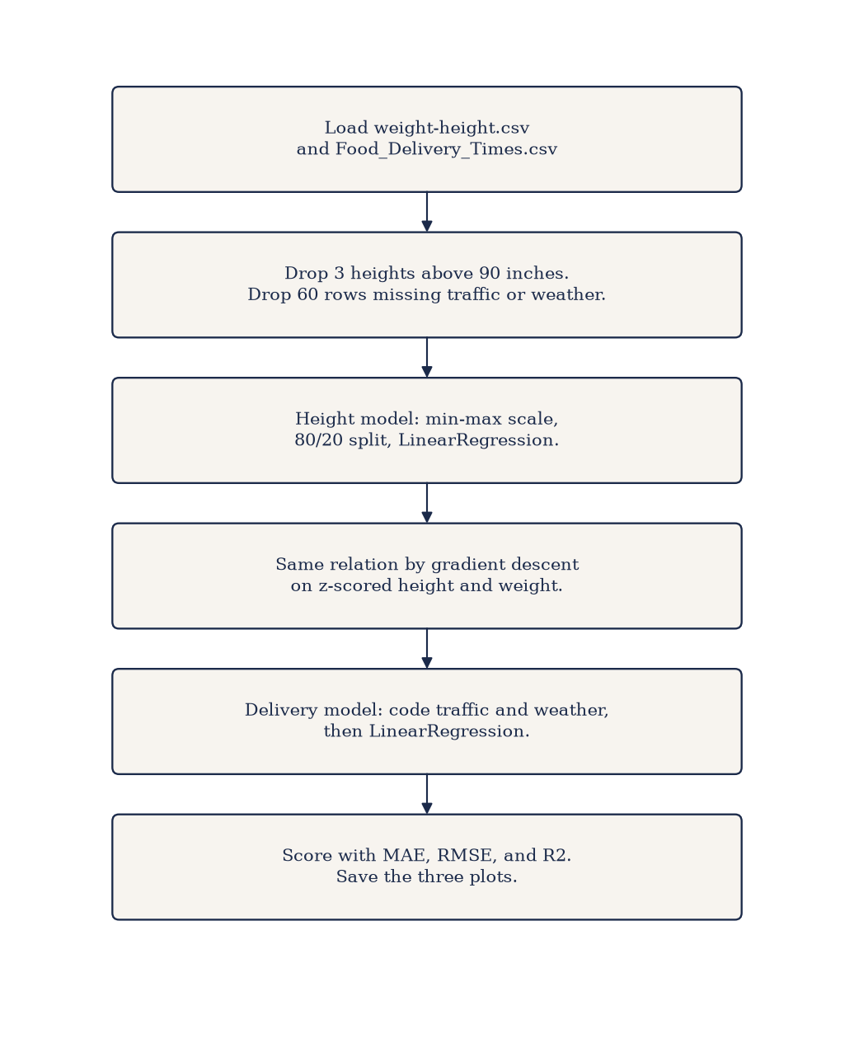
Figure 1. Pipeline for the height model, the gradient-descent check, and the delivery model.

Algorithm
- Start. Import numpy, pandas, scikit-learn, and matplotlib.
- Load weight-height.csv and Food_Delivery_Times.csv. Print the shape and the null counts.
- Drop rows whose height is above 90 inches. Min-max scale Height and Weight on the rows that remain.
- Set X to scaled height and Y to scaled weight. Split 80/20 with random_state 67.
- Fit LinearRegression. Print the slope, the intercept, and the test MSE, RMSE, MAE, and R2. Convert the test errors back to pounds.
- Plot the test points and the fitted line, sorted by height.
- Reload the cleaned height table. Z-score X and Y, add a column of ones, and run gradient descent for 1,000 steps at learning rate 0.1.
- Compare the learned theta with the least-squares solution, and plot MSE against the iteration.
- On the delivery table, drop rows missing Traffic_Level or Weather. Code traffic as 1, 2, 3 and weather as indicators against Clear.
- Fit LinearRegression for Delivery_Time_min. Print test MAE, RMSE, and R2, the coefficients in minutes, and the mean-predictor MAE. Plot actual against predicted.
- End.

Height and weight
On the test set the line explains 0.8531 of the variance in scaled weight. The typical miss is 9.91 pounds (MAE) and the root mean squared error is 12.36 pounds. R2 is unchanged by the conversion back to pounds, because that conversion is linear.

Measure | Result
Rows kept | 9,997 of 10,000
Train / test | 7,997 / 2,000
Pearson r | 0.9248
Scaled slope | 0.9284
Scaled intercept | 0.0174
Slope in pounds per inch | 7.71
Test R2 | 0.8531
Test MAE | 9.91 pounds
Test RMSE | 12.36 pounds
Figure 2 shows the test points and the line. Taller people weigh more, and the line sits through the middle of the cloud.
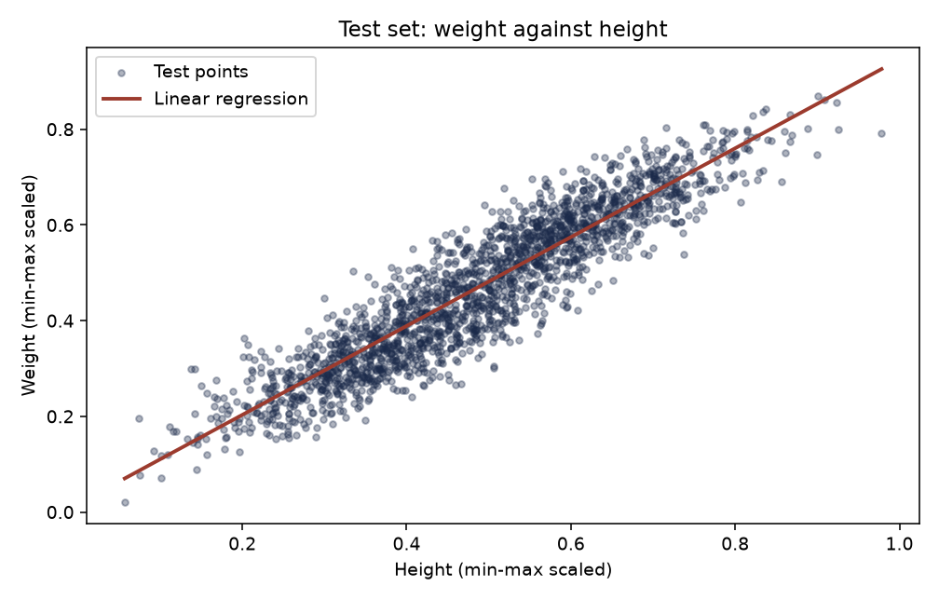
Figure 2. Test set: scaled weight against scaled height, with the fitted line.

Gradient descent
Mean squared error starts at 1.0, is 0.144773 at iteration 50, and is 0.144745 at iteration 1,000. The intercept is 0 and the slope is 0.9248, the same values as the closed form, and the slope matches the Pearson correlation. Figure 3 is flat after the first few dozen steps, so 1,000 iterations is more than the fit needs.
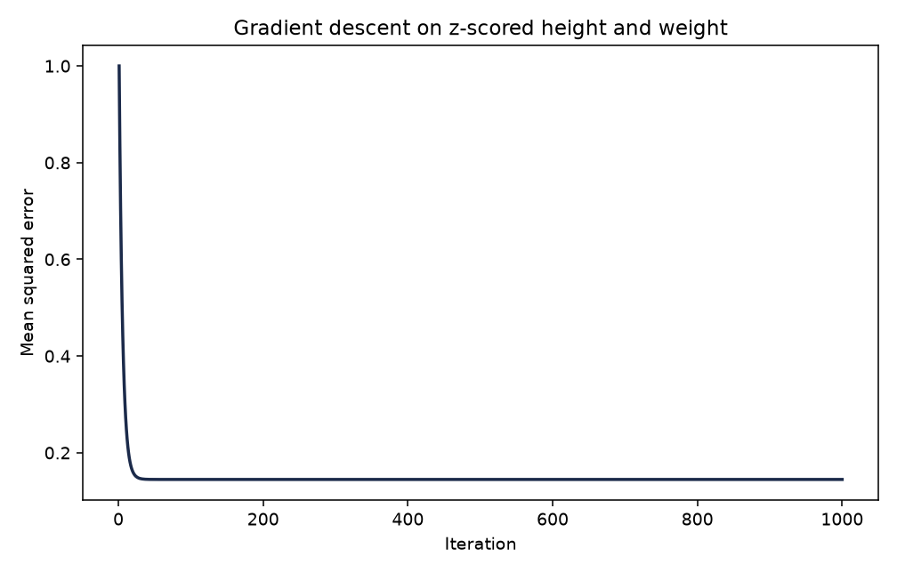
Figure 3. Mean squared error during gradient descent on z-scored height and weight.

Food delivery time
The test MAE is 6.49 minutes and the test RMSE is 10.16 minutes. R2 is 0.7684. Predicting every test order with the training mean misses by 17.11 minutes, so the line is the better of the two. Each extra kilometre adds 3.02 minutes. Each extra minute of preparation adds 1.02 minutes. Each step up in traffic (Low to Medium, or Medium to High) adds 5.69 minutes. Against clear weather, fog adds 9.48 minutes, rain 5.82, snow 10.39, and wind 2.75.
The intercept is -4.88 minutes. It is the prediction at zero distance, zero preparation, traffic code 0, and clear weather. Traffic in this table starts at 1, so that point is outside the data and the intercept is not itself a delivery time.

Term | Minutes | Reading
Intercept | -4.88 | Outside the observed range
Distance_km | 3.02 | Per extra kilometre
Preparation_Time_min | 1.02 | Per extra minute of preparation
Traffic (1, 2, 3) | 5.69 | Per step from Low toward High
Weather Foggy | 9.48 | Versus Clear
Weather Rainy | 5.82 | Versus Clear
Weather Snowy | 10.39 | Versus Clear
Weather Windy | 2.75 | Versus Clear
Figure 4 plots the 188 test orders. Points near the diagonal are close calls. A few long deliveries fall well below the line, which is why the RMSE (10.16 minutes) is larger than the MAE (6.49 minutes).
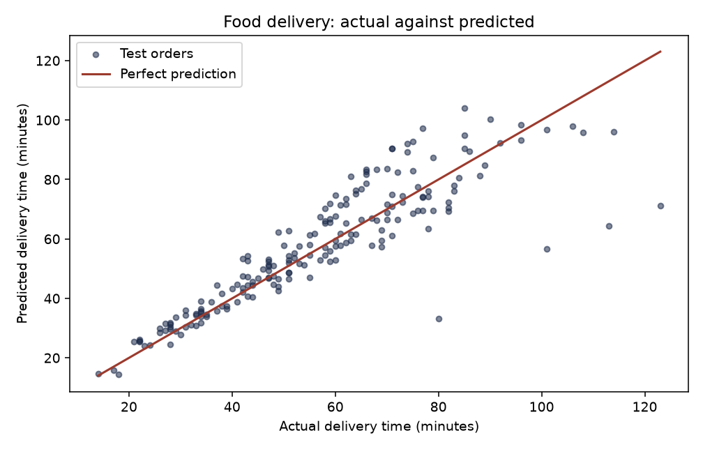
Figure 4. Actual delivery time against the predicted time on the test orders.

Result
Height predicts weight with a test R2 of 0.8531 and a test MAE of 9.91 pounds. Gradient descent on the z-scored table reaches the same slope as least squares, 0.9248. On the delivery orders the line cuts the typical error from 17.11 minutes to 6.49 minutes, with a test R2 of 0.7684. Distance, preparation, traffic, and bad weather all add minutes, and snow is the largest weather gap versus a clear day.

GitHub
Course repository: https://github.com/francisreubenr-rvu/Data-Science-Labs
The executed notebook is Ex.No.5.ipynb in Semester-3/Labs-Semester-3/Lab 05. The upload copy is 1RUA25CSE0168_Francis_Reuben_R_Lab5.ipynb. Outputs are saved in the file.

